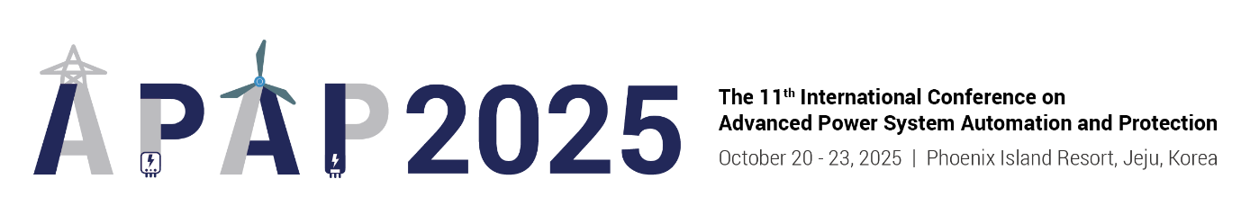

**Room Reservation Application (APAP 2025)**

**◎ Participants who want to stay should fill out the information below and reply by e-mail.**

**E-mail:** **mice.phoenix1@gmail.com**

**◎** **Email reservations are not made in real time, and if you want a quick reservation,**

**please make a reservation in the reservation room.**

**◎ After the reservation is completed, a reservation text will be sent to your phone number.**

**◎ Room type is on-site assignment and cannot be pre-designated.**

**◎ The deadline for reservations is September 5, 2025 (Friday). (First-come, first-served)**

|  |  |  |  |  |  |  |  |
| --- | --- | --- | --- | --- | --- | --- | --- |
| **Name** |  | | | **The Number of Guests** | | **( ) Persons** | |
| **Phone Number** |  | | | **E-mail** | |  | |
| **Event Schedule: October 20th (Mon) to October 24th (Fri): 4 Nights and 5 Days** | | | | | | | |
| **Room Type** | **Application Rate**  **(per night)** | | **Check-in Date** | | **Room Night** | **Number of Rooms** | **The Number of Guests** |
| **Royal**  **(34평 / 112㎡)** | **10/20~23** | **KRW 200,000** |  | |  |  |  |
| **10/24~25** | **KRW 270,000** |  | |  |  |  |
| **Royal Suite**  **(54평 / 178.2㎡)** | **10/20~23** | **KRW 330,000** |  | |  |  |  |
| **10/24~25** | **KRW 400,000** |  | |  |  |  |
| **Other** | **\* The above applicable fee is based on the date of stay and includes Room Only / tax.** | | | | | | |
| **Additional Matters** | | | | | | | |
| **◎ Breakfast buffet fee: KRW 39,000 per person (on-site payment)**  **◎ Addition of room number: KRW 33,000 per person (on-site payment)** | | | | | | | |
| **Payment Method** | | | | | | | |
| **◎ On-site payment at check-in**  **◎ We need to open the card related to the cancellation penalty, so please enter your card information.** | | | | | | | |
| **Card Number** |  | | | **Validity** | |  | |
| **Cancellation/Change Penalty Regulation** | | | | | | | |
| **◎ Apply the total amount booked as of the date of arrival**  **◎ No penalty 7 days ago, 10% 6-4 days ago, 20% 3-2 days ago, 50% 1 day ago, canceled/not arrived on the**  **same day.**  **◎ The cancellation/change penalty will be paid with an open card.** | | | | | | | |
| **Reservation Acceptance and Contact Information** | | | | | | | |
| **◎ Phoenix Island Reservation Room  T. 1577-0069(#1) F. 02-2031-1490  E. mice.phoenix1@gmail.com H.** [**http://phoenixhnr.co.kr/jeju/index**](http://phoenixhnr.co.kr/jeju/index) | | | | | | | |

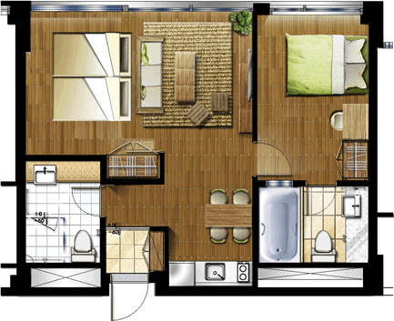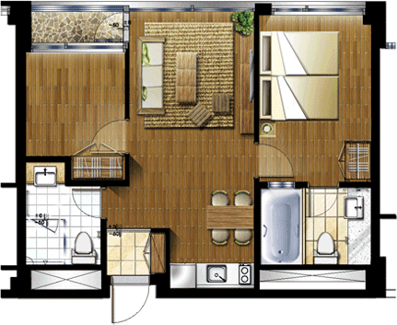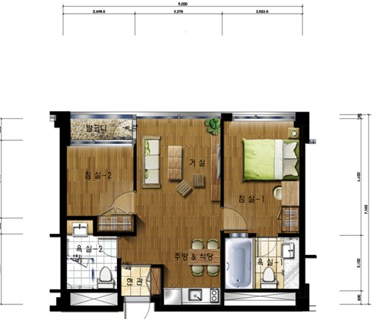**1) Royal type (34 floor plan / 1 room for 4 people)**

|  |  |  |
| --- | --- | --- |
| **Royal Double Ondol**  **(Double Bed + Ondol Room)** | **Royal Twin Ondol**  **(Twin Bed + Ondol Room)** | **Royal Double Twin**  **(Double Bed + Twin Bed)** |

**2) Royal Sweet Type (54 Flat / 1 room for 6 people)**

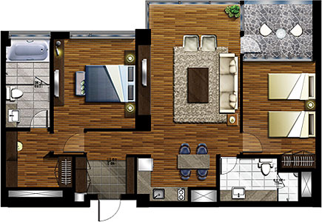 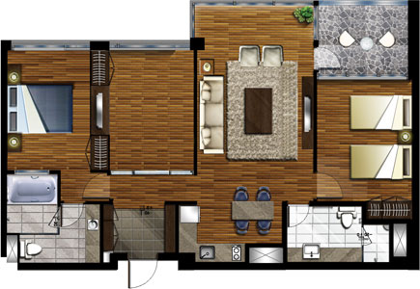

|  |  |
| --- | --- |
| **Royal Sweet A**  **(Double Bed + Twin Bed)** | **Royal Sweet B**  **(Double Bed + Ondol Room + Twin Bed)** |

**3) Check-in/check-out**

|  |  |  |  |
| --- | --- | --- | --- |
| **Check-in** | 15:00~ | **checkout** | ~11:00 |

**\* When extended to check-out: KRW 10,000 / KRW 14:00 20,000 / KRW 15:00 KRW 30,000 / KRW 1 night after 15:00**

**4) Others**

**\* Breakfast: Cozy on the 1st floor of Building B (07:00-10:00), 43,000 won per person / per session -> guest discount of 39,000 won per person**

**\* Living room LCD TV, bathroom TV, bidet (2), multi air conditioner (living room, room), telephone, refrigerator (150L), table, microwave,  
Electric kettle, dryer, wash towel, shampoo, conditioner, body wash, soap**

**\* 220V, cable broadcasting (26 channels), wireless Internet (free) - (ID: Room number / PW: No)  
* Free bottled water (one time at admission)  
* The towel replacement will be carried out upon your request, and it will be replaced once a night.  
* Room cleaning is provided free of charge once only for more than three nights.  
* All charges are tax-inclusive.**