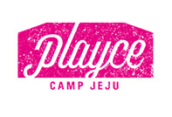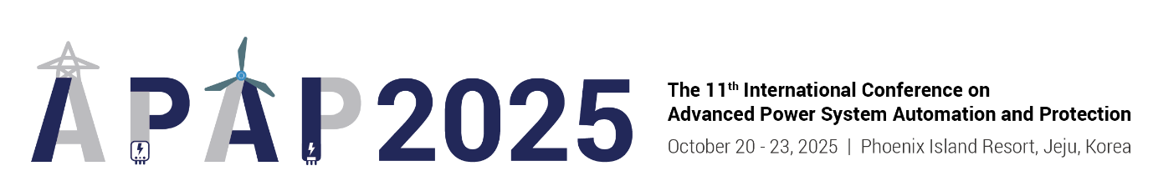

**Room Reservation Application (APAP 2025)**

**◎ Participants who want to stay should fill out the information below and reply by e-mail.**

**E.** **mice.phoenix1@gmail.com**

**◎** **Email reservations are not made in real time, and if you want a quick reservation, please make a reservation**

**in the reservation room.**

**◎ After the reservation is completed, a reservation text will be sent to your phone number.**

**◎ The deadline for reservations is September 5, 2025 (Friday). (First-come, first-served)**

|  |  |  |  |  |  |  |
| --- | --- | --- | --- | --- | --- | --- |
| **Name** |  | | **The Number of Guests** | | **[One Person Only]** | |
| **Phone Number** |  | | **E-mail** | |  | |
| **Event schedule: October 20th (Mon) to October 24th (Fri): 4 nights and 5 days** | | | | | | |
| **Room Type** | **Application Rate**  **(per night)** | **Check-in Date** | | **Room Night** | **Number of Rooms** | **The Number of Guests** |
| **Standard (STD)** | **KRW 44,000** |  | |  |  |  |
| **Standard Plus**  **(SPD)** | **KRW 55,000** |  | |  |  |  |
| **Deluxe (DLX)** | **KRW 99,000** |  | |  |  |  |
| **Deluxe** | **\* The above applicable fee is based on the date of stay and includes Room Only / tax.** | | | | | |
| **Additional Matters** | | | | | | |
| **◎ All rooms reserved for one person**  **◎ Room Only / Weekdays/Weekdays Same rate applied** | | | | | | |
| **Payment Method** | | | | | | |
| **◎ On-site payment at check-in**  **◎ We need to open the card related to the cancellation penalty,**  **so please enter your card information.** | | | | | | |
| **Card Number** |  | | **Validity** | |  | |
| **Cancellation/Change Penalty Regulation** | | | | | | |
| **◎ Apply the total amount booked as of the date of arrival**  **◎ No penalty 7 days ago, 10% 6-4 days ago, 20% 3-2 days ago, 50% 1 day ago, canceled/not arrived on the same day**  **◎ The cancellation/change penalty will be paid with an open card.** | | | | | | |
| **Reservation Acceptance and Contact Information** | | | | | | |
| **◎ Playce Camp Reservation Room  T. T. 1577-0069(#1) F. 02-2031-1490  E. mice.phoenix1@gmail.com H. https://phoenixhnr.co.kr/static/playcecamp/guide/intro** | | | | | | |

**1) Standard (STD): Square View/City View (3.3 pyeong)**

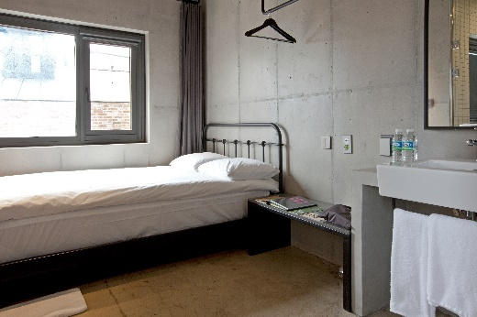 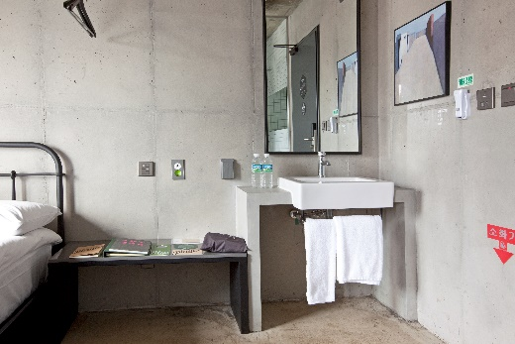

**2) Deluxe (DLX): Square View/Forrest View (6.6 pyeong)**

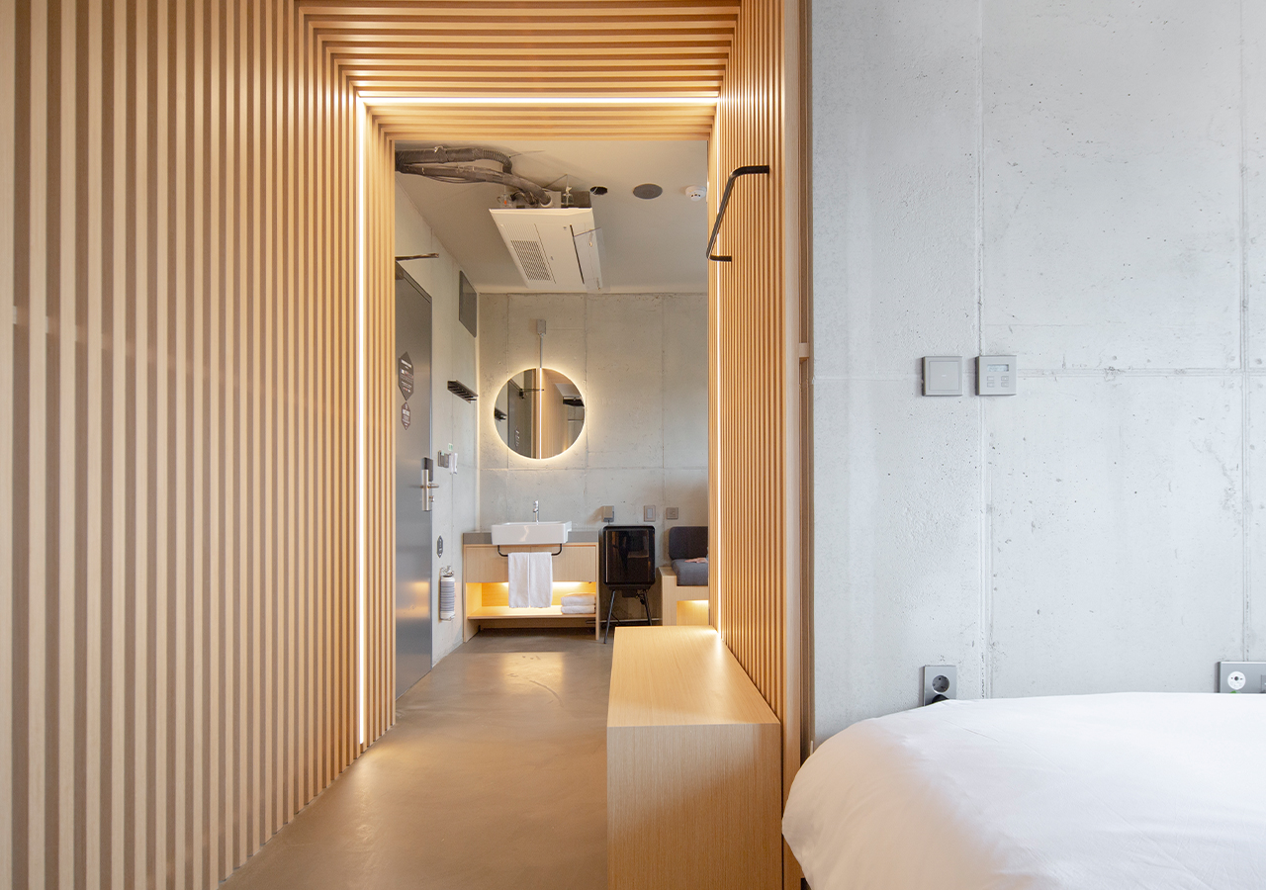 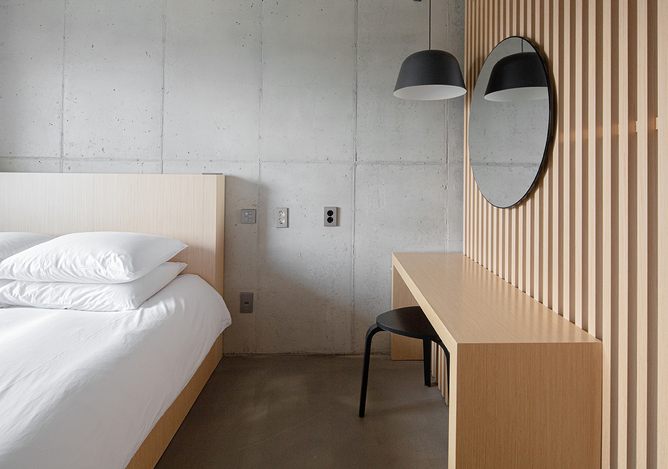 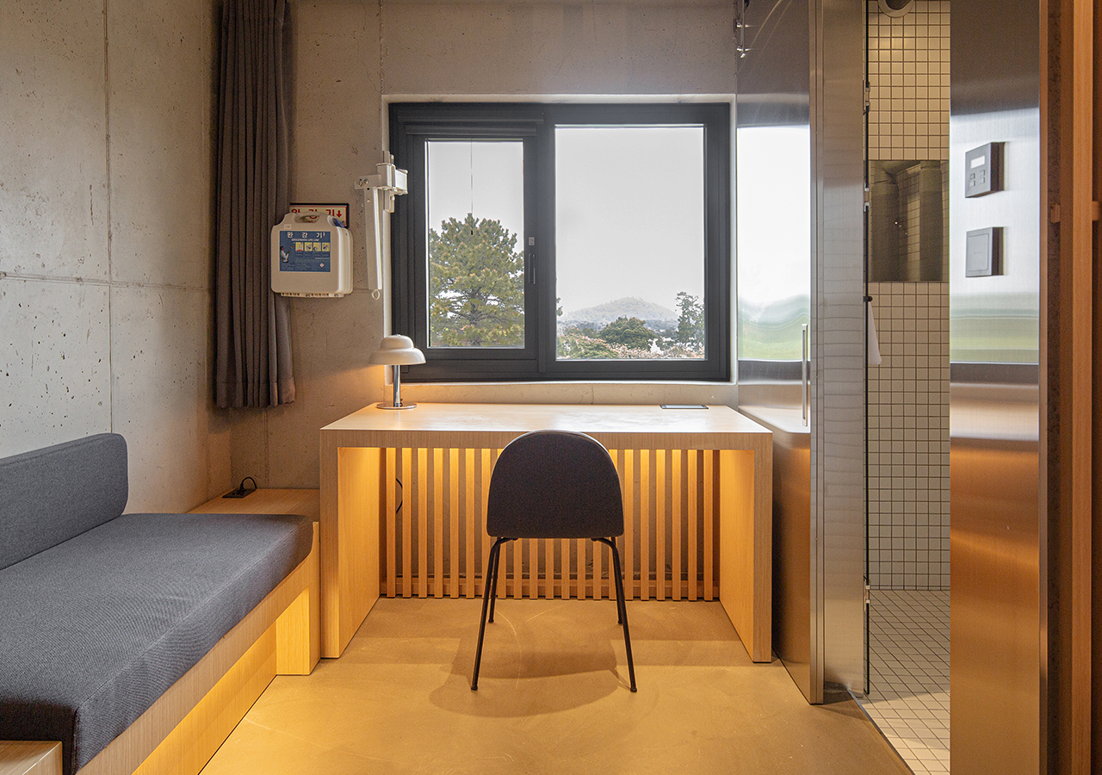

**4) Check-in/check-out**

|  |  |  |  |
| --- | --- | --- | --- |
| **Check-in** | 14:00~ | **Check-out** | ~11:00 |

**\* If the check-out is extended: 30% of the 1 night fee at 15:00 / 50% of the 1 night fee at 17:00 / 1 night fee after 17:00**

**5) Others**

**\* Simmons Mattress, Hungarian Angus Bedding, Refrigerator, Hair Dryer, Shampoo/Rins/Body Wash/Hand Wash, Face Towel/Bast Towel, 1 bottle of bottled water / Beam projector (DLX only)**

**(Toothbrush/toothpaste is for personal use)**

**\* Wi-fi (free)-(ID: Room number / PW: None)**

**\* All charges are tax-inclusive.**